29.39:In a superconductor there is no internal magnetic field, and so there is no changing flux and no induced emf, and no induced electric field.
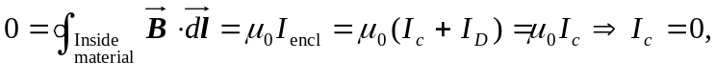
and so there is no current inside the material. Therefore, it must all be at the surface of the cylinder.

